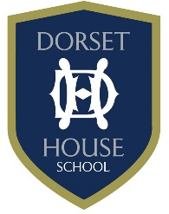
External Speakers
Date | Name of Speaker | Event | Year Groups | Checks | Notes
08 May 17 | Father Jeremais | Assembly | All | Google search

