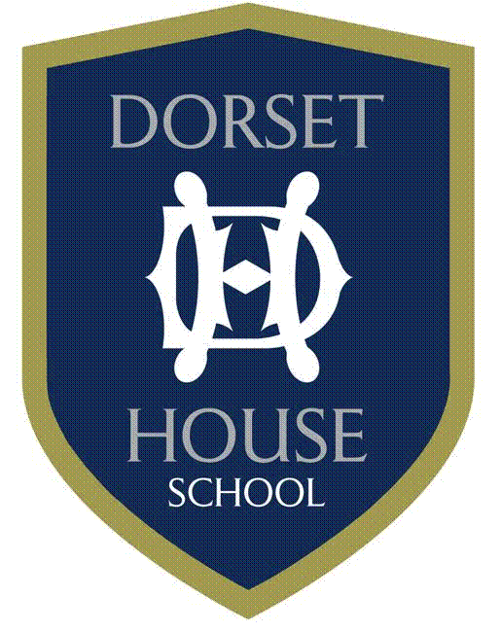
Spring Term & Winter Uniform
Girls’ Uniform List – Year 5 to Year 8
Item | Compulsory/Optional | Supplier
Navy DH Logo Blazer (for matches/outings/formal occasions) | C | S
Grey Cardigan | C | S
Blue long sleeve shirt, revere collar | C | S
Tartan Skirt | C | S
Grey socks | C | O
Black school shoes | C
Navy waterproof coat | C | S
DH Logo Beanie | O | S

Spring Term & Winter Uniform
Boys’ Uniform List – Year 5 to Year 8
Item | Compulsory/Optional | Supplier
Navy DH Logo Blazer (for matches/outings/formal occasions) | C | S
Grey DH Jumper | C | S
Long sleeve blue shirt | C | S
Grey cord Shorts – above the knee | C | S
Grey cord trousers | O | S
Charcoal Grey trousers (matches/outings/formal occasions) | C | S
School Tie | C | S
Grey Socks | C | S/O
Navy waterproof coat | C | S
DH Logo Beanie | O | S

