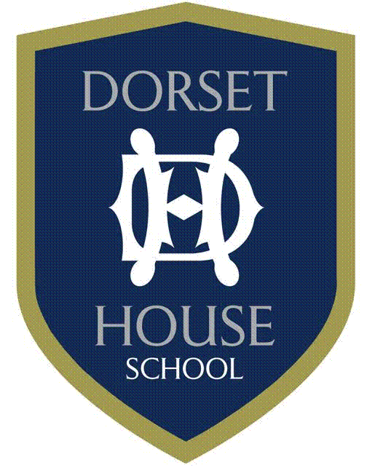
Spring Term & Winter Uniform
GIRLS’
Year 3 to Year 8- Sports Kit
Games
Skort (Navy and Pale) | C | S
Games Polo Shirt (Navy and Sky) | C | S
Track pants with Logo (Navy) | C | S
Mid Layer Top with Logo (Navy) | C | S
Long Blue DHS socks | C | S
Base Layer Top (DHS) | O | S
Base Layer Leggings (DHS) | O | S
PE
PE/Athletic Shorts (Navy) | C | S
White Socks | C
Footwear & Extras
Trainers | C
Astro Trainers | C
Bootbag | O | S
Sports bag | C | S
Water bottle | O | S

C | Compulsory
O | Optional
S | Stevenson’s

Spring Term & Winter Uniform
BOYS’
Year 3 to Year 8- Sports Kit
Games
Track pants with logo (Navy) | C | S
Mid Layer Top with logo (Navy) | C | S
Blue Shorts with logo (Navy) | C | S
Rugby Shirt | C | S
Long Blue DHS socks | C | S
PE
DH Polo Shirt (Sky) | C | S
PE Cotton Shorts (White) | C | S
White Socks | C
Footwear & Extras
Trainers | C
Astro Trainers | C
Rugby/Football Boots | C
Sports Bag | C | S
Water Bottle | O | S
Boot bag | O | S
Towel | C

C | Compulsory
O | Optional
S | Stevenson’s

